

**SCHOOL OF COMPUTER SCIENCE**

**Docker Lab File**

**Submitted by**

|  |  |
| --- | --- |
| **Name** | **Kashish** |
| **Branch** | **BTech CSE(DevOps)B-1(NH)** |
| **Semester** | **5** |
| **SAPID** | **500107137** |
| **Roll no** | **R2142220335** |

**Lab Exercise 3: Working with Docker Volumes**

**Objective:**

* Learn how to create and manage Docker volumes.
* Understand how Docker volumes can be used to persist data across container restarts.
* Practice mounting Docker volumes to containers.

**Prerequisites:**

* Docker installed on your system.
* Basic understanding of Docker commands and container concepts.

**Step 1: Create a Docker Volume**

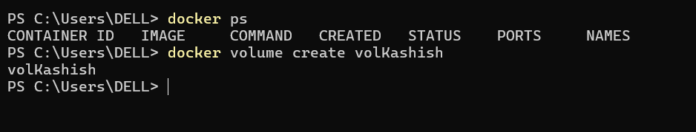

Verify that the volume was created:

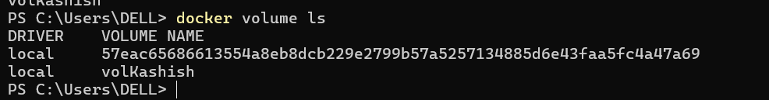

**Step 2: Run a Container with the Volume Mounted**

Run a Nginx container with the volume mounted:

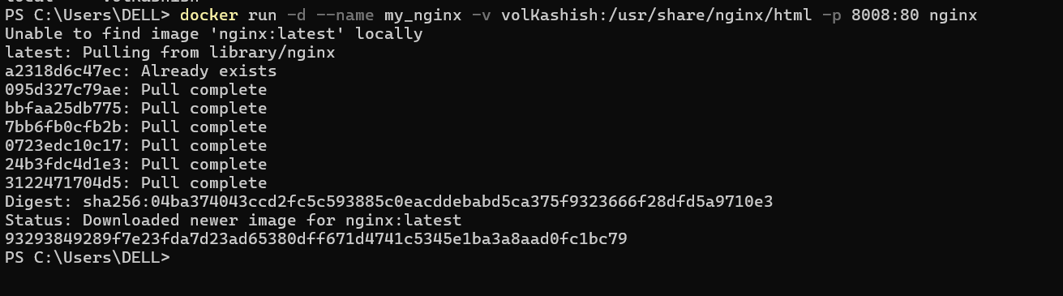

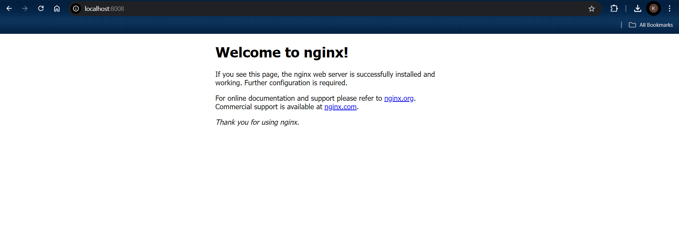

Verify that the container is running:



**Step 3: Interact with the Volume**

Create a simple HTML file in the volume:

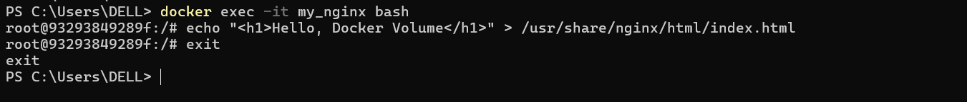

Browser Page

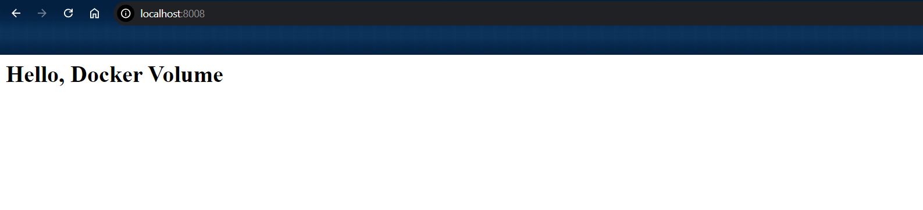

**Step 4: Test Data Persistence**

Stop and remove the container:

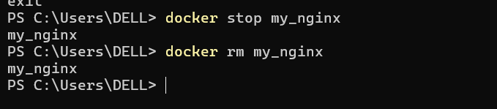

Run a new Nginx container using the same volume:

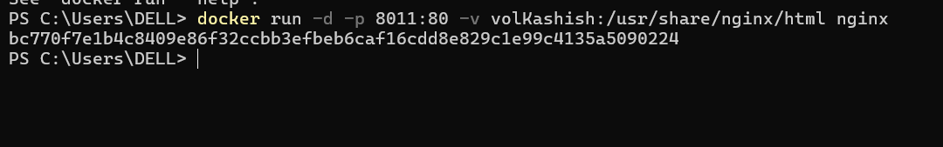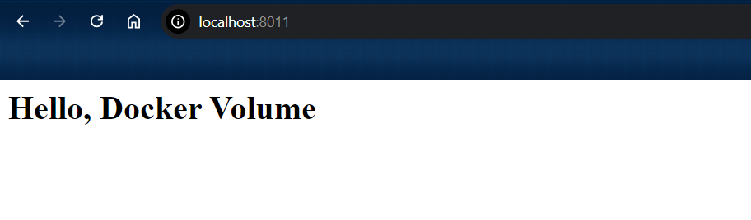

**Step 5: Clean Up**

Stop and remove the container:

Remove the Docker volume:

Verify that the volume is removed:

